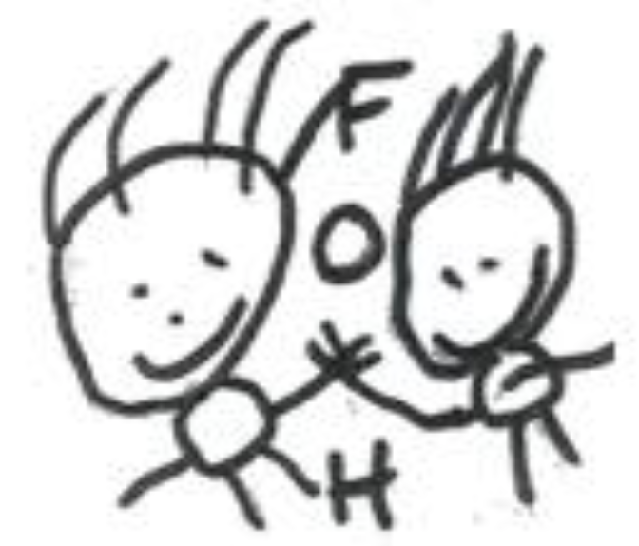
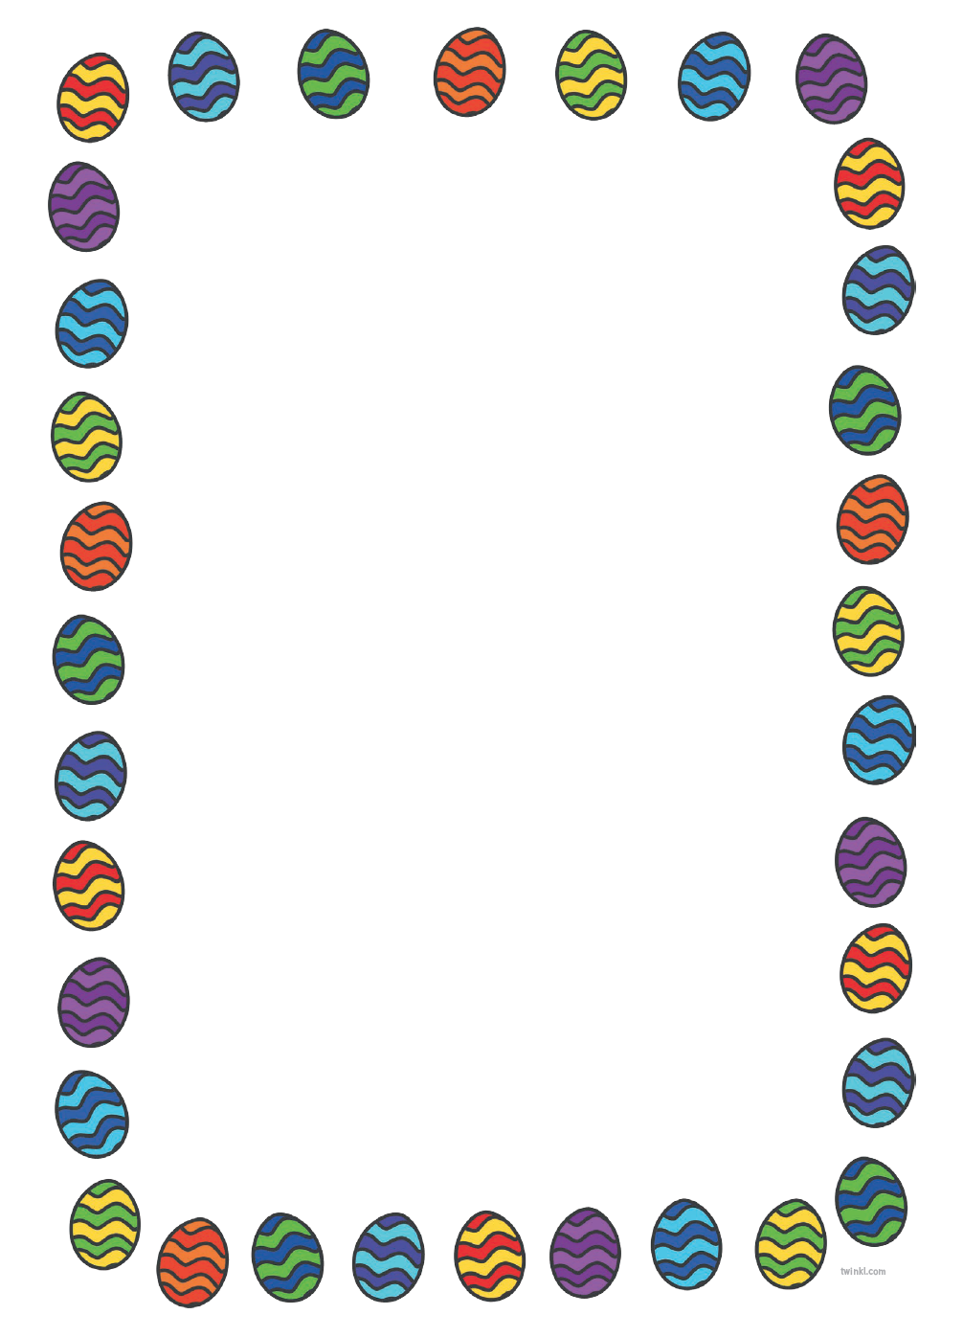

Family and Friends of Hebden Green School

Easter Bingo

It will soon be time for our annual Easter Bingo, which will take place on Wednesday 28th March 2018. Doors will open at 6.30pm. Bingo tickets will be sold at £1 per book for a set of 5 games. Light refreshments will be served on the evening.

We kindly invite your children to come into school wearing non-uniform on Friday 23rd March 2018 in return for an Easter egg that will go towards bingo prizes on the evening.

As you may know, last year’s Easter Bingo was a huge success and very busy so please arrive from 6.30pm to avoid disappointment. We look forward to seeing everyone for some Easter fun!

Clare McCabe and the FFoHGS

